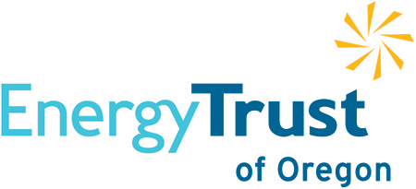
Commercial SEM
Final Participant Report
2019
Central Oregon Community College

Genevieve London
1001 SE Water Ave. STE. 370
Portland, OR., 97214
303-815-5289
glondon@stillwaterenergy.com
Gerard O’Sullivan
623 SW Oak Ave., 3rd Floor
Portland, OR., 97205
503-858-8943
gosullivan@aesc-inc.com

Table of Contents
1. Energy Savings Summary Table 3
2. Executive Summary 4
3. Program Highlights 4
4. Participant Energy Team 5
5. Plans for Future Success 5

Central oregon community college
March 20, 2020
- Energy Savings Summary Table
This table includes information related to Central Oregon Community College’s (COCC) three enrolled buildings. The “Electric/Gas Baseline” is the annual energy consumption during the baseline period in the model. “Modeled Savings” is the total savings for the current program year from the CUSUM; “Net Savings” is the “Modeled Savings” with all capital projects deducted that have been completed since the baseline was established; “Incremental Savings” is the SEM savings claimed and incentivized from the site for the current program year; and “Sum of Total Incentive” is “Incremental Electric/Gas Savings” multiplied by the per kWh/Therm incentive for current SEM Program Year.
Overall, COCC achieved 1.9% electric and an impressive 13.4% gas savings compared to their baseline annual energy consumption. Wikiup Residence Hall (Wikiup) delivered all the electrical savings, with 4.7% savings compared to the baseline. The energy performance for both the Redmond Technology Education Center (RTEC) and Wikiup began to trend positively in the second half of the year and will continue to perform well through 2020.
The energy savings and incentives for each site are detailed in the tables below. At the incentive rate of $0.02/kWh & $0.20/therm, the total energy savings incentive is $327.

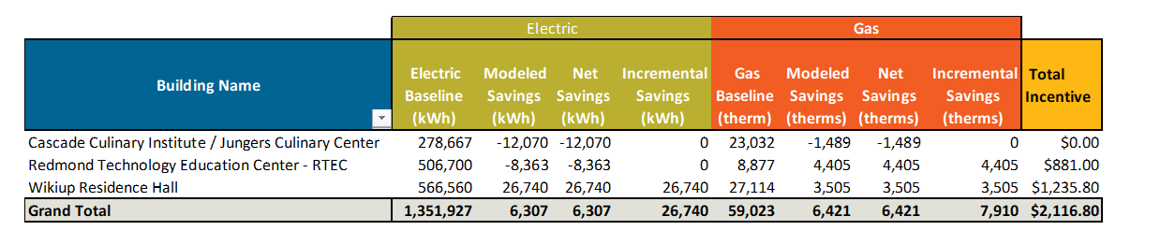

2019 KPIs
Milestones Achieved:
☒ Energy Team | ☒ EMA Action Plan
☒ Performance Tracking | ☒ Executive Sponsor Engagement
☒ Energy Policy
Milestones Incentive Amount: | $5,000
Intern Incentive Amount: | $6,564.50
Total Combined Incentive Amount | $13,681.30
Percentage of Workshops Attended: | 100%
EMA Total Score / Year over Year Score: (optional 2018) | 2019 – 15%

- Executive Summary
Central Oregon Community College, 2600 NW College Way, Bend, OR., 97703-5933
Although COCC was not formally enrolled in the program until 2019, COCC’s students have been involved in the program for several years as Strategic Energy Management (SEM) interns for several Central Oregon Cohort participant organizations. They remain key in providing a pipeline for SEM interns across the Cohort. Although it can be a challenge to join a mature SEM cohort like the Central Oregon Cohort, COCC ramped up quickly and did not shy away from asking questions and jumping in. COCC achieved all five of their 2019 milestones. Many of these milestones are foundational tenants of SEM, including adopting an Energy Policy, building an Energy Team and maturing in their usage of their Performance Tracking Tool.
The COCC Team will remain focused on building upon and deepening their SEM practices and driving staff, student and executive engagement for 2020 and beyond. This year, the COCC Team achieved $7,116.80 in gas, electric and milestone incentives.

- Program Highlights
As a first-year participant, COCC was not afraid to jump in and host the first workshop, join partner peer coaching calls and analyze energy data from the Performance Tracking Tool. This year COCC focused on building the foundations of SEM. They have an Energy Team that meets on a regular basis, an engaged and enthusiastic executive sponsor and an effective SEM intern. COCC worked diligently to implement an Energy Policy and incorporate it into the campus’ sustainability plan. In additional organizational milestones, COCC completed many of their Opportunity Register projects and are creating documentation to institutionalize SEM.

- Organizational Activities:
  - Successes
    - Early on in the 2019 program year, COCC engaged residence halls in an energy competition. Energy Champion Dana Christensen developed engaging materials to support this effort and saw energy savings impacts.
  - Challenges
    - Initially, COCC was challenged by a lack of buy-in from staff and students. Over the course of their first year in the program COCC recruited new members for their Energy Team, hired an intern and maintained strong executive engagement.
  - Progress
    - In addition to building support for SEM, COCC has become versatile in the Performance Tracking Tool and uses it to investigate anomalies and share results with both the Energy Team and Executive Team.
- Technical Activities:
  - Successes
    - COCC conducted their first Building Opportunity Assessment (BOA) at all three buildings with the assistance of the Energy Coaches, their Energy Team and representatives from the culinary center and residence hall staff.
  - Challenges
    - COCC was challenged to get projects implemented early in the program. There were several competing commitments occurring concurrently with the launch of the SEM engagement. As a result, most of their projects were completed late in the year and did not achieve SEM energy savings until later in 2019.
  - Progress
    - As a first-year participant entering into a cohort with many mature organizations, the COCC Team was able to launch an Energy Team and implement projects yielding significant electrical and gas savings at the RTEC and Wikiup Residence Hall.
- Participant Energy Team

Energy Champion: Dana Christensen, Instructional Deans Assistant
Executive Sponsor: Joe Viola, Campus Services Director
Back-up Energy Champion: Jessica Russell, Assistant II Professor, Health and Human Performance
Team Member:
Barbara Bellinger, Site Coordinator Wickiup Hall/Student Engagement
Laura Hagen, Site Coordinator Culinary Building
Courtney Nolta, Site Coordinator, Boyle Education Center
John Lutje, HVAC Specialist
Christin Sands, Billing Coordinator
Amy Wheary, Site Coordinator Health Careers Center
Brian Nelson, Site Coordinator Redmond Campus
Intern: Jillian DiMedio
The COCC Energy Team is a diverse and cross-functional group. Energy Team members represent different sites within the SEM portfolio and diverse functional area specialists including engagement, awareness, Information Technologies and education. Energy Champion Dana Christenson has excelled in championing SEM efforts across the campus and has built a supportive and collaborative community. After overcoming funding challenges, Dana was able to hire an SEM intern who has been crucial in policy development and prioritizing SEM projects.
Bruce Tuckman’s Forming-Storming-Norming-Performing model of group development proposes that each stage is necessary and inevitable for the team to grow, face challenges, tackle problems, find solutions, plan work and deliver results. The COCC Team belongs in the “Norming” stage as they continue to define roles and responsibilities and gain and maintain buy-in from key stakeholders.

☐ Forming | ☐ Storming | ☒ Norming | ☐ Performing | ☐ Reforming

- Plans for Future Success
COCC has re-enrolled for 2020. With a full year of SEM under their belt they have the foundational pieces of SEM in place and are ready to maximize their SEM savings. With their current building portfolio staying the same, they will work to prioritize remaining projects on their Opportunity Registers while ramping up engagement efforts and driving energy efficient behavior.

- COCC will conduct a BOA at their Redmond Campus next year. As BOA outputs, COCC will have a complete Opportunity Register and assign Redmond Energy Team members project tasks.
- COCC plans to engage and empower staff through enacting a start-up and shut down checklist in their culinary facility.
- With momentum from their 2019 performance year and greater buy-in across campus, COCC will see an uptick in SEM savings and project completion.

