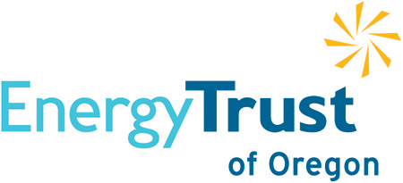
Strategic Energy Management
2020 Impact Report
Central Oregon Community College

Central Oregon Community College
March 31, 2021
- Executive Summary
 |  | In their second year of Energy Trust’s Strategic Energy Management (SEM) program, Central Oregon Community College (COCC) focused on building upon the success of their first year by focusing on two foundational elements: documentation, and projects. COCC worked diligently to implement a standard operating procedure on their HVAC setpoints and incorporate it into their campus’ sustainability plan and completed lighting projects.  This year, the COCC team achieved $5,179 in energy incentives and milestone incentives.
- Energy Savings Summary
 |  | This methodology uses engagement and program historical savings rates to determine savings for each site, which is the current basis for paying incentives. Engagement is assessed through Performance Tracking Tool (PTT) updates, workshop attendance, monthly call attendance, and the number of projects completed. To calculate energy savings, historical savings rates are determined by building type, model age, and fuel type which is applied to each enrolled site.  Normally savings are calculated with meter-level energy models in participant PTTs. The extraordinary circumstances of 2020 have required that Energy Trust adapt commercial SEM savings methodologies and program offerings. Energy Trust is only permitted to account for savings and pay incentives for efforts that are directly attributed to participation in Energy Trust programs and will result in savings over future years. As a result, a new way to calculate savings and incentives for the full year has been developed. In 2020, SEM Savings will be recognized and incentivized if you:  - Implemented at least five opportunities that were identified on your Annual Energy Plan  - And you completed at least one of the following:  - Attended 50% of operations calls  - Attended 50% of core SEM workshops  - Updated all PTTs at least 4 times  Following are tables showing Program Year 2020 engagement criteria and savings, and below the tables are notes describing what each column represents.

Engagement Metrics for Program Savings
Number of Workshops Attended | 3/6
Number of Operations Calls Attended | 6/12
Number of times Performance Tracking Tools Were Updated | 2
Total Number of Completed Projects | 5

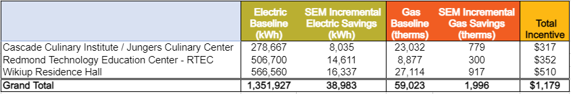
Electric/Gas Baseline is the annual energy use during the period prior to the program/model start date.
SEM Incremental Savings includes savings specific to SEM activities that occurred in the current engagement year (does not include capital savings). For continuation participants, this is your incremental incentivized savings that exceed SEM savings from previous years.
Total Incentive is the SEM Incremental Savings (kWh) x $0.02 plus Incremental Savings (therms) x $0.20.
Key Performance Indicators
Milestones Achieved:
☒ Annual Energy Plan | ☐ Energy O&M Projects  0 /10 complete
☒ Standard Operating Procedure | ☐ Executive Sponsor Engagement
☒ Energy Team | ☐ Internship Assistance Milestone
☒ Standard Operating Procedure - Resiliency
Treasure Hunts Conducted | 0
EMA Total Score / Year over Year Score (optional 2019) | 2019 – 15%
Milestones Incentive Amount | $4,000
Intern Incentive Amount | N/A
Energy Savings Incentive Amount  (see table for details) | $1,179
Total Combined Incentive Amount | $5,179

- Program Highlights
 |  | COCC successfully completed their second year in Energy Trust’s Strategic Energy Management Program. The team continues to see the value in the SEM cohort as an opportunity to learn from fellow energy practitioners and hear best practices across industries. This year, the team used the learnings from unoccupied buildings during the pandemic to build a more robust strategy on HVAC temperature setpoints and increase their understanding of how they can be adjusted for lower occupancy periods.  The organizational and technical activities that are in bold indicate items that were part of the organization’s COVID (or wildfire) response.

- Organizational Activities:
  - Successes.
    - COCC made great strides this year institutionalizing SEM across their sites. Energy Champion, Dana Christensen, was instrumental in the development and implementation of Standard Operating Procedures (SOPs). The COCC team developed documentation for resiliency practices as well as HVAC temperature set points.
  - Challenges.
    - The Sustainability Committee is a key stakeholder group in SEM efforts at COCC. The Sustainability Chair is transitioning in 2020 to a new position, this will impact roles and responsibilities of the Energy Champion, Energy Team and Executive Sponsor. During this transition Executive Sponsor, Joe Viola, has done an excellent job filling in for the Energy Champion role.
  - Progress.
    - Despite significant COVID-19 impacts the COCC Energy Team maintained a steady focus on SEM. Dana and Joe worked tirelessly to uncover energy efficiency opportunities, attend workshops, and convene Energy Team meetings.
- Technical Activities:
  - Successes.
    - The COCC Energy Team navigated a challenging year and completed energy projects at each of their sites. The sites in the SEM portfolio were included in a major campus-wide lighting upgrade leading to significant energy savings.
  - Challenges.
    - Administrative support for the energy team decreased over the year as the college’s focus shifted towards COVID-19 response and student enrollment, which made it harder for the energy team to implement their SEM vision.
  - Progress.
    - COCC has already identified several energy saving projects that they would like to implement in the new year including HVAC maintenance and thermostat setpoint changes. With Dana, Joe, and the new Sustainability Chair, COCC’s energy team has the right leadership in place to achieve their SEM goals.
- Participant Energy Team
 |  | Energy Champion: Dana Christensen, Instructional Deans Assistant  Executive Sponsor: Joe Viola, Director of Campus Services  Data Champion: Jillian DiMedio, Sustainability and Energy Management Coordinator  Team Member: Kelly Ruebush, HVAC Specialist  Team Member: Brian Nelson, Building Maintenance Specialist  The COCC Energy Team is a diverse and cross-functional group and serves as a subset of the Sustainability Committee. Both Energy Champion Dana Christensen and Executive Sponsor Joe Viola, have excelled in championing SEM efforts across the campus and have built a supportive and collaborative community. Due to budgetary impacts from COVID-19 the Sustainability Committee was unable to approve the hiring of 2020 intern.  Phases reference Tuckman’s stages of growth development. Forming-storming-norming-performing model of group development proposes that each stage is necessary and inevitable for the team to grow, face challenges, tackle problems, find solutions, plan work, and deliver results. The COCC Team belongs in the “Norming” stage as they continue to define roles and responsibilities and gain and maintain buy-in from key stakeholders.

Energy Team Phase
☐ Forming | ☐ Storming | ☒ Norming | ☐ Performing | ☐ Reforming

- Plans for Future Success
 |  | In 2020, Central Oregon Community College completed a campus-wide lighting upgrade which led to a significant energy reduction for all buildings. COCC plans to prioritize hiring a dedicated SEM intern in 2021. This will help formalize the roles and responsibilities of SEM related tasks. COCC has successfully hired and onboarded an SEM intern in the past. They may choose to leverage these findings.

- Energy performance and review is a key focus area for COCC. The COCC Energy Team outlined this as an EMA Action Item to track and progress on in the coming years.
- COCC intends to conduct a virtual Treasure Hunt at an additional site in their portfolio. Due to COVID a second Treasure Hunt was not conducted in 2020. COCC would benefit from additional Operations and Maintenance project identification and related energy savings.

This report was prepared by:
Primary Coach: Gerard O’Sullivan
Phone: 503-858-8943
e-mail: gosullivan@aesc-inc.com

